

NSN 4G Parsing

FRS (Functional Requirement Specifications)
Auto-Import
Indrasan Yadav
04-06-2025

Change History

Version | Change Description | Author | Date
0.1 | First draft. | Indrasan Yadav | 29-05-2025
0.2 | Added case for SRAN where classes contain extra tags in section 11. | Indrasan Yadav | 11-08-2025

PREAMBLE
- This document specifies how to parse the logical inventory attributes for the eNodeB and its cells.
- It covers the parameters defined for eNodeB RAN logical attributes.
- The provided dump files are of “.xml”.
- This is motivated by Airtel Projects and can be used for other operators having same file structure.
- Another source type of dump files could be provided later for Antenna attributes.

Connector name
Ooredoo Tunisia_NSN_RAN

Connector Information
- The dump file is an “.xml” file composed of set of Managed Objects.
- Each Managed Object starts with “<managedObject “and ends with “</managedObject>”.
- Inside each managed object, there is a Tag name, followed by “attributes” and finally by the different set of parameters with their values.

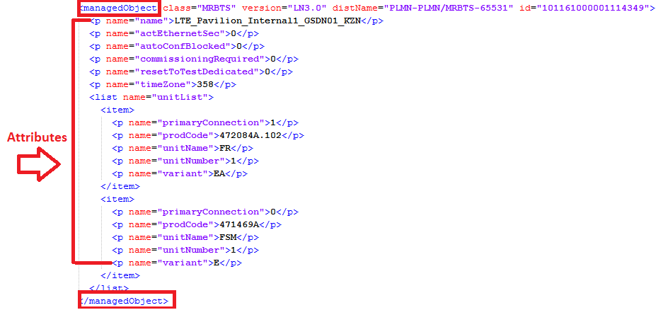

ENODEB logical parameters
The eNodeB logical inventory attributes are classified accordingly in the below categories:
  - Global Parameters
  - Networking Parameters
  - Radio Parameters
  - Cell Parameters

- Note: The internal mapping between the Physical and Logical parameters will be based on the Node ID.
- Note: If the Node ID parsed from the logical dumps wasn’t matched with the Node ID of the physical connector , hence remove the digit “0” from the Node ID parsed from the physical connector, where the digit “0” is found directly after the 1st digit as follow : PLMN-PLMN/MRBTS-X0XXXX PLMN-PLMN/MRBTS-XXXXX
  - E.g.: PLMN-PLMN/MRBTS-605531 PLMN-PLMN/MRBTS-65531

Global Parameters
The below global attributes defined at eNodeB level are as follows:

Class=“MRBTS”

Attributes | Importance | Example
eNodeB ID | [Mandatory] | - = “distName” attribute under the <managedObject Tag with having the “class=“LNBTS”.  - E.g.: <managedObject class="LNBTS" version="xL24R2_2404_110" distName="PLMN-PLMN/MRBTS-15142/LNBTS-15142" id="104777">  eNodeB ID = 15142  - If class=”LNBTS” is not found, then take it from class=”MRBTS”  - E.g: <managedObject class="MRBTS" version="SBTS24R2_2325_100" distName="PLMN-PLMN/MRBTS-15142" id="103327">  eNodeB ID =15142
eNodeB Name | [Mandatory] | - From class=”LNBTS”, take attribute “name” (<p name="name">TUNL142</p>), if name doesn’t exist then take “enbName” (<p name="enbName">TUNL142</p>). LNBTS would exist under corresponding MRBTS or SBTS class.  - 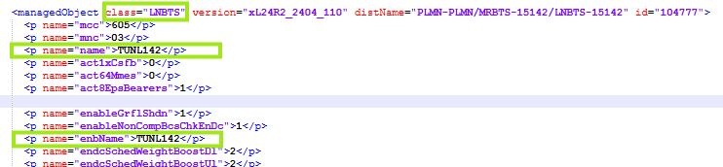
Site Id | [Mandatory] | - To be explained later once complete site information & dump will be received from customer.
Site Name | [Mandatory] | - Site Id
Type | [Mandatory] | - = eNodeB
OAM IP | [Optional] | - =“oamIpAddr” attribute associated with the <managedObject Tag having the “class” attribute = “IPNO”  - E.g.: <p name="oamIpAddr">10.96.151.97</p>…  OAM IP = 10.96.151.97
OAM Subnet Mask | [Optional] | - OAM IP is consisting of 4 numbers separated with”.”(e.g. 10.96.151.97).  - OAM Subnet Mask to be deduced based on the first number of the OAM IP as per below:  - <=127255.0.0.0  - <=191 or >=128 255.255.0.0  - >=192 255.255.255.0  - E.g.: OAM IP = 10.96.151.97 OAM Subnet Mask = 255.0.0.0

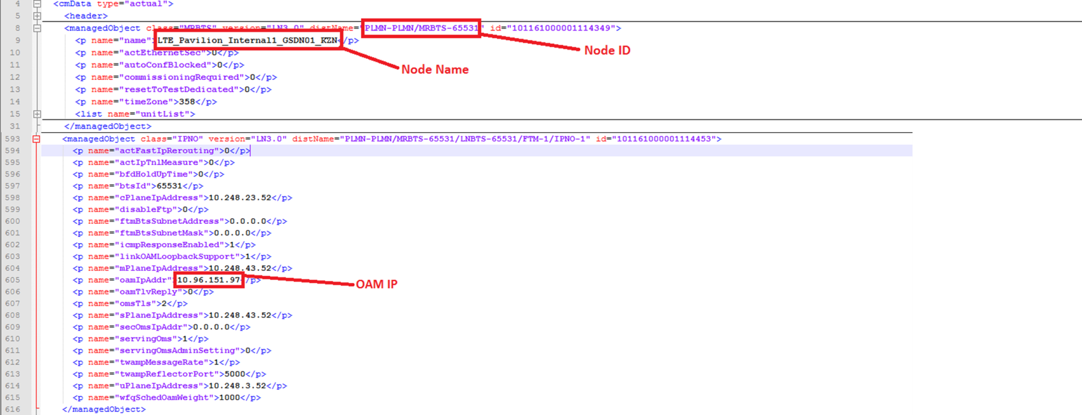

Networking Parameters
The below networking attributes defined at eNodeB level are as follows:

Attributes | Importance | Example
MCC | [Mandatory] | - = “mcc” attribute under the <p Tag associated with the <managedObject Tag having the “class” attribute = “LNBTS”  - E.g.: <p name="mcc">605</p>  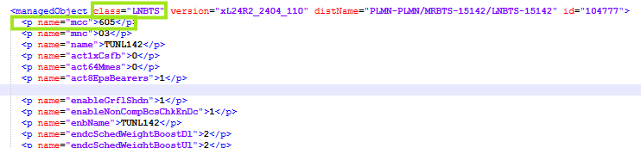  - The “name” attribute mentioned under same class=”LNBTS” refers the node name.
MNC | [Mandatory] | - =”mnc” attribute under the <p Tag associated with the <managedObject Tag having the “class” attribute = “LNBTS”  - E.g.: <p name="mnc">03</p>  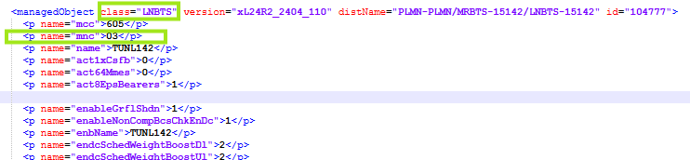  - The “name” attribute mentioned under same class=”LNBTS” refers the node name.
TAC list | [Optional] | - =NEP tool calculated, TAC list of children cells.
Parent MMEs | [Optional] | - More than one Parent MME could exist per each node.  - The Parent MMEs Name is extracted according to the following steps:  - = “value” concatenated with the “name” attribute having a “value” = “mmeName” under the <p present underneath the <managedObject Tag having the “class” attribute = “LNMME”  - Therefore check if more than one “class” attribute=”LNMME” having different “mmeName” value. if yes, all the associated “mmeName” values are to be parsed.  - E.g.:  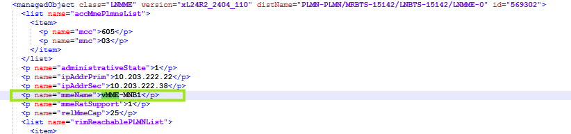  - Parent MME is deduced by matching Parent MME Name deduced from dumps with Column A in MME sheet in Parent_MME_SGW.xlsx matching file, if found then Parent MME is the value in column B on the same line, Else consider same value deduced from Dumps.  - Matching file to be provided later.
Parent SGWs | [Optional] | - More than one Parent SGWs could exist per each node.  - The Parent SGWs Name is extracted according to the following steps:  - = “value” concatenated with the “name” attribute having a “value” = “sgwIpAddress” under the <p Tag associated with the <item> Tag located inside the <list> Tag present underneath the <managedObject Tag having the “class” attribute = “GTPU”  - Therefore check if more than one “class” attribute=” GTPU” having different “sgwIpAddress” value. If yes all the associated “sgwIpAddress” values are to be parsed.  - Under Class = GTPU”listitempname="sgwIpAddress”  - E.g.: <p name="sgwIpAddress">10.41.4.5</p>  - Parent SGW is deduced by matching Parent SGW Name deduced from dumps with Column A in SGW sheet in Parent_MME_SGW.xlsx matching file, if found then Parent SGW is the value in column B on the same line, Else consider same value deduced from Dumps.  - Matching file to be provided later.
Served Cells | [Optional] | - NEP tool calculated.
Connected eNodeBs | [Optional] | - For each node there exists a set of connected eNodeBs.  Each eNodeB is referred to by <managedObject class="LNADJ", whose name was already parsed by extracting the “name” attribute (name="name">LTE_Broadway_GSDN01_KZN</p>)  - The “connected eNodeBs” attribute refers to the IDs of each of the connected eNodeBs, and could be obtained following the below steps:  - Under each <managedObject class=“LNADJ”, extract the name=“adjEnbId” attribute.  - E.g.: <p name="adjEnbId">631071</p>  - Concatenate each parsed value with the key word “PLMN-PLMN/MRBTS-“to get the full node ID.  - E.g.: PLMN-PLMN/MRBTS-631071  - If there is no matching concatenate it with the Key word “PLMN-PLMN/SBTS-“  - E.g.: PLMN-PLMN/SBTS-631071  - The Name of each “connected eNodeBs” can be then deduced through the node ID.  Note: If same “adjEnbId” was detected, ignore the repeated value.

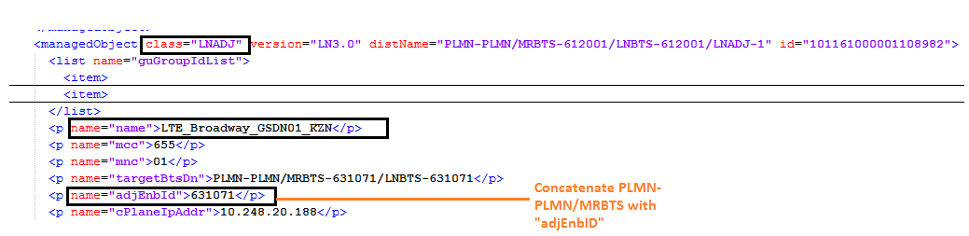

Radio Parameters
The following table summarizes the radio attributes, which have default value at catalog level but can be imported and editable at instance level.

Attribute | Importance | Example
TDD enabled | [Optional] | - each eNodeB has multiple cell  - TDD enabled:  - if at least one cell have these attributes tddFrameConf and tddSpecSubfConf under class=“LNCEL”  - example: <managedObject class="LNCEL" version="TL16A" distName="PLMN-PLMN/MRBTS-XXX/LNBTS-XXX/LNCEL-Y  <p name="tddFrameConf">2</p>  <p name="tddSpecSubfConf">7</p>  Then TDD is enabled, otherwise it will be FDD.  And FDD details will be find in class=”LNCEL_FDD”.
Operational Frequency bands for FDD | [Optional] | - Only if the value of “redirRat” is equal to “2” , follow the below steps:  - Get each “earfcnDL” found under each <managedObject class=“LNCEL”.  - Note: If same “earfcnDl” was found, ignore the repeated values and take only one value.  - Check to which “Value Range” the obtained value belongs to, then take the value under “Band” column.  - The Operation Frequancy bands for FDD will be then “FDD_” concatenated with the value under the “Band”.  - E.g.: "earfcnDL">1800</p> Value Range is 1200-1949 , therefore the Band is equal to 3, “hence the Operational Frequency bands for FDD” will be equal to FDD_3  - Note: In case of different values of “earfcnDL” were found list them all.  - FDD_3 , FDD_5 , FDD_20
  Band | Value Range
  1 | 0 – 599
  2 | 600 – 1199
  3 | 1200 – 1949
  4 | 1950 – 2399
  5 | 2400 – 2649
  6 | 2650 – 2749
  7 | 2750 – 3449
  8 | 3450 – 3799
  9 | 3800 – 4149
  10 | 4150 – 4749
  11 | 4750 – 4949
  12 | 5010 – 5179
  13 | 5180 – 5279
  14 | 5280 – 5379
  17 | 5730 – 5849
  18 | 5850 – 5999
  19 | 6000 – 6149
  20 | 6150 – 6449
  21 | 6450 – 6599
  22 | 6600 – 7399
  23 | 7500 – 7699
  24 | 7700 – 8039
  25 | 8040 – 8689
  26 | 8690 – 9039
  27 | 9040 – 9209
  28 | 9210 – 9659
  29 | 9660 – 9769
  30 | 9770 – 9869
  31 | 9870 – 9919
Operational Frequency bands for TDD | [Optional] | - Only if “TDD supported” is enabled , follow the below steps :  - Get each “earfcn” found under each <managedObject class=“LNCEL”.  - Note: If same “earfcn” was found, ignore the repeated values and take only one value.  - Check to which “Value Range” the obtained value belongs to, then take the value under “Band” column.  - The Operation Frequency bands for TDD will be then a concatenation of “TDD_” with the matched value under “Band” Column.  - E.g.: "earfcn ">1800</p> Value Range is 1200-1949, therefore the Band is equal to 3, “hence the Operational Frequency bands for FDD” will be equal to “FDD_3”.  - Note: In case of different values of “earfcnDL” were found list them all.  - TDD_41 , TDD_43 , TDD_44
  Band | Value Range
  33
   | 36000-36199
  34
   | 36200-36349
  35
   | 36350-36949
  36
   | 36950-37549
  37
   | 37550-37749
  38
   | 37750-38249
  39
   | 38250-38649
  40
   | 38650-39649
  41
   | 39650-41589
  42
   | 41590-43589
  43
   | 43590-45589
  44
   | 45590-46589
Supported Bandwidths | [Optional] | - Get the deduced Band value obtained from the Band column present in the “Operational Frequency bands for TDD” table or “Operational Frequency bands for FDD” table, and match it in the below table. Once matched, get the value of corresponding supported bandwidths:
  Band | Supported Bandwidths
  1 | 5, 10, 15, 20
  2 | 1.4, 3, 5, 10, 15, 20
  3 | 1.4, 3, 5, 10, 15, 20
  4 | 1.4, 3, 5, 10, 15, 20
  5 | 1.4, 3, 5, 10
  7 | 5, 10, 15, 20
  8 | 1.4, 3, 5, 10
  9 | 5, 10, 15, 20
  10 | 5, 10, 15, 20
  11 | 5, 10
  12 | 1.4, 3, 5, 10
  13 | 5, 10
  14 | 5, 10
  17 | 5, 10
  18 | 5, 10, 15
  19 | 5, 10, 15
  20 | 5, 10, 15, 20
  21 | 5, 10, 15
  22 | 5, 10, 15, 20
  23 | 1.4, 3, 5, 10
  24 | 5, 10
  25 | 1.4, 3, 5, 10, 15, 20
  26 | 1.4, 3, 5, 10, 15
  27 | 1.4, 3, 5, 10, 15
  28 | 5, 10, 15, 20
  28 | 5, 10
  30 | 5, 10
  33 | 5, 10, 15, 20
  34 | 5, 10, 15
  35 | 1.4, 3, 5, 10, 15, 20
  36 | 1.4, 3, 5, 10, 15, 20
  37 | 5, 10, 15, 20
  38 | 5, 10, 15, 20
  39 | 5, 10, 15, 20
  40 | 5, 10, 15, 20
  41 | 5, 10, 15, 20
  42 | 5, 10, 15, 20
  43 | 5, 10, 15, 20
  44 | 5, 10, 15, 20
Uplink 64-QAM enabled | [Optional] | (catalog Level)
ICIC enabled | [Optional] | (catalog Level)

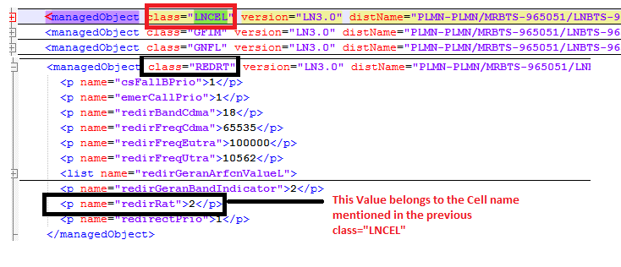

Cell Logical Parameters

Attributes | Importance | Comment
Node ID | Mandatory | - = “distName” attribute under the <managedObject Tag with having the “class” attribute = “MRBTS” OR “class” attribute =“SBTS”  - E.g.: <managedObject class="MRBTS" version="LN3.0" distName="PLMN-PLMN/MRBTS-65531" id="101161000001114349">  Node ID = PLMN-PLMN/MRBTS-65531  - E.g.: <managedObject class="MRBTS" version="LN3.0" distName="PLMN-PLMN/SBTS-65531" id="101161000001114349">  - Node ID = PLMN-PLMN/SBTS-65531
Parent Site ID | Mandatory | - (NEP tool calculated)
Cell ID | Mandatory | - It is equal to the concentration of the Node ID with the local cell ID from the distName where class=“LNCEL”  - Example:  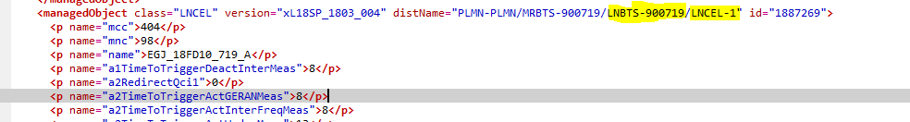  Separate LNBTS and LNCEL with “-“  Example :LNBTS= 900719, cell ID= 1 cell ID =900719-1  In case of the Node Id contain MRBTS or SBTS remove it from the cell ID
Cell Name | Optional | - Get the different Cell Name values for each node as follows:  Under class="LNCEL"  - E.g.: <p name="name">LTE_Galleria_Int_GSDN01_KZN_1</p>  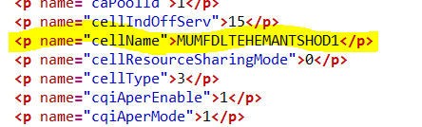
External Code | Mandatory | - Is the concatenation of “EnodeBID”, “_” and “Cell ID”.  - “eNodeBID” = “distName” attribute under the <managedObject Tag with having the “class” attribute = “MRBTS” OR “SBTS”  - = CellId equals class="LNCEL" under "distName" attribute and after the keyword "LNCEL-"  - E.g. PLMN-PLMN/MRBTS-65531_14541.
Cell Technology | Optional | - = NEP tool calculated, Else =”LTE”.
MCC | [Mandatory] | - = “mcc” attribute under the <p Tag associated with the <managedObject Tag having the “class” attribute = “LNCEL”  - E.g.: name="mcc">655</p>  - The “name” attribute mentioned under same class=”LNCEL” refers the node name.
MNC | [Mandatory] | - =”mnc” attribute under the <p Tag associated with the <managedObject Tag having the “class” attribute = “LNCEL”  - E.g.: name="mnc">01</p>  - The “name” attribute mentioned under same class=”LNCEL” refers the node name.
Neighbor Cells 2G | Optional | - Under each class="LNCEL" there exist several class="LNRELG"  - Get the different “Neighbor Cells 2G” ID values as follows :  It is a concatenation of :”LAC”,”_” and ”Cell_ID” as follow:  - The “Cell_ID” and “Lac” are exctracted under each class="LNRELG"pname=“ci” and name="lac"  - E.g.: <p name="ci"> 10563 </p>  - <p name="lac">307</p>  E.g.:307_10563  - The obtained values refer to the Cell_ID obtained under same class="LNCEL"
Neighbor Cells 3G | Optional | - Under each class="LNCEL" there exist several class="LNRELW"  - Get the different "Neighbor Cells 3G" ID values as follows:  - It is a concatenation of “LAC” , “_” and “Cell_ID” as follow:  Under each class="LNRELW"pname=“uTargetCid” and name="uTargetLac  - E.g.: <p <p name="uTargetCid "> 5531 </p>  - <p name="uTargetLac">3021</p>  E.g.:3021_5531  - If the class=“uTargetLac” is not found  - Neighbor Cell Rnc ID= class=“uTargetRncId"  - Neighbor Cell ID= class="uTargetCid"  - Match the neighbor Cell Id with Cell ID in the same Rnc ID  - The obtained values refer to the Cell_ID obtained under same class=”LNCEL”
Neighbor Cells 4G | Optional | - For each Cell there exists more than one Neighbouring Cell_ID.  - Under each class="LNCEL" you will find several class="LNREL" this will lead us to know the “Neighbor Cells 4G” as follow :  - Get under each class="LNREL" whenever exists, the name="ecgiAdjEnbId" value.  - For each of these obtained values match it with name=" ecgiAdjEnbId" under each class="LNADJL"  - Once matched get the value of “phyCellId” and “tac” under the same class="LNADJL"  - Then search for the same distName="PLMN-PLMN/MRBTS-x” where x represents the “ecgiAdjEnbId” , if there no match search for distName="PLMN-PLMN/SBTS-x”  - Once matched lookup for the same "phyCellId" and “tac” value under class="LNCEL"  - The Cell that possesses a value under LNCELlistpname=“phyCellId” and “tac” which matches the original retrieved value is the Cell whose ID to be taken from this same class=”LNCEL” line using the rule as aforementioned in the Cell ID section.  - This process is repeated for every Neighbouring cell corresponding to a certain eNodeB node.

Neighbor Cells 4G:

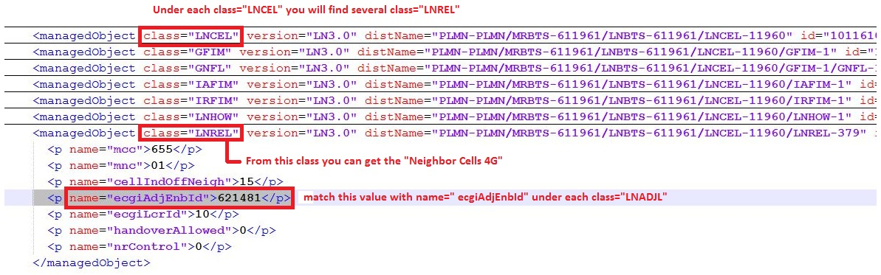

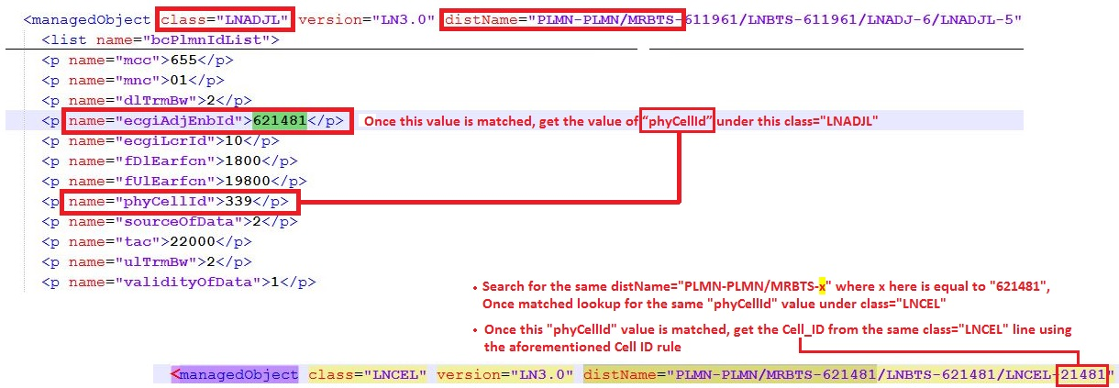

- Specific attributes for 4G cells
Attributes | Example | Comments
Cell Duplexing Mode | Optional | - under class=“LNCEL”  - If these attributes exist “tddFrameConf” and “tddSpecSubfConf”, then it is TDD  - If not exist then check above attributes in class  class="LNCEL_TDD”, which would be under the corresponding LNCEL class. E.g  class="LNCEL_TDD" version="TL17A_1701_07_1701_06" distName="PLMN-PLMN/MRBTS-801068/LNBTS-801068/LNCEL-2/LNCEL_TDD-0  If attributes exist here, then its TDD, otherwise FDD.
PCID | Optional | - Under Class=”LNCEL” name="phyCellId”  - "E.g.: <PhyCellId>185</PhyCellId>
TAC list | Optional | - Under : Class=”LNCEL” name="tac"  - E.g.: name="tac">21000</p>  - This value is the same for all the cells under a specific node.
Downlink Bandwidths | Optional | - For FDD: Based on the value of “dlChBw”, the “Downlink Bandwidths” will be deduced.  - It is found Under : Class=”LNCEL” name="dlChBw"  E.g.: name="dlChBw">50</p>  If not found under class=”LNCEL”, then check under class="LNCEL_FDD" which would be under the corresponding LNCEL e.g class="LNCEL_FDD" version="FL17A_1701_07_1701_06" distName="PLMN-PLMN/MRBTS-254/LNBTS-254/LNCEL-1/LNCEL_FDD-0  - For TDD Based on the value of “ChBw”, the “Downlink Bandwidths” will be deduced.  - It is found Under: class=”LNCEL” name="ChBw"  E.g.: name="ChBw">200</p>  if not found under class=”LNCEL” then check under class="LNCEL_TDD" which would be under the corresponding LNCEL  - Divide the value of dlChBw/ChBw by 10 to obtain  Downlink Bandwidth E.g.: name="ChBw">200</p>  Then bandwidth will be 20
Uplink Bandwidths | Optional | - For FDD: Based on the value of “ulChBw”, the “Uplink Bandwidths” will be deduced.  - It is found Under: class=”LNCEL” name="ulChBw"  E.g.: name="ulChBw">50</p>  If not found under class=”LNCEL”, then check under class="LNCEL_FDD" which would be under the corresponding LNCEL  For TDD: Uplink Bandwidth= Downlink Bandwidth  - Divide the value of ulChBw/ChBw by 10 to obtain  Uplink Bandwidth E.g.: name="ChBw">200</p>  Then bandwidth will be 20
Downlink Earfcn | Optional | - For FDD: Under class=”LNCEL”name="earfcnDL"  E.g.: name="earfcnDL">1800</p>  If not found under class=”LNCEL”, then check under class="LNCEL_FDD" which would be under the corresponding LNCEL e.g class="LNCEL_FDD" version="FL17A_1701_07_1701_06" distName="PLMN-PLMN/MRBTS-254/LNBTS-254/LNCEL-1/LNCEL_FDD-0  - For TDD Under: class=”LNCEL”name=" earfcn", if not found under class=”LNCEL” then check under class="LNCEL_TDD" which would be under the corresponding LNCEL. For TDD cell Downlink Earfcn= Uplink Earfcn
Uplink Earfcn | Optional | - Under: class=”LNCEL”name=" earfcnUL"  E.g.: name="earfcnUL">19800</p>  If not found under class=”LNCEL”, then check under class="LNCEL_FDD" which would be under the corresponding LNCEL e.g. class="LNCEL_FDD" version="FL17A_1701_07_1701_06" distName="PLMN-PLMN/MRBTS-254/LNBTS-254/LNCEL-1/LNCEL_FDD-0  - For TDD Under: class=”LNCEL”name=" earfcn", if not found under class=”LNCEL” then check under class="LNCEL_TDD" which would be under the corresponding LNCEL. For TDD cell Downlink Earfcn= Uplink Earfcn
MIMO configuration | Optional | - For FDD: Following the value of “dlMimoMode”, the “MIMO configuration” will be deduced.  - “dlMimoMode” is found under Class=”LNCEL” name="dlMimoMode"  E.g.: name="dlMimoMode">40</p>  If not found under class=”LNCEL”, then check under class="LNCEL_FDD" which would be under the corresponding LNCEL e.g class="LNCEL_FDD" version="FL17A_1701_07_1701_06" distName="PLMN-PLMN/MRBTS-254/LNBTS-254/LNCEL-1/LNCEL_FDD-0  - For TDD: Following the value of “dlMimoMode”, the “MIMO configuration” will be deduced.  - “dlMimoMode” is found under class=”LNCEL” name="dlMimoMode"  E.g.: name="dlMimoMode">40</p>  if not found under class=”LNCEL” then check under class="LNCEL_TDD" which would be under the corresponding LNCEL  Below mapping to be used to get mimo configuration from dlMimoMode  - 0 : SingleTX;  10 : TXDiv;  11 : 4-way TXDiv;  30 : Dynamic Open Loop MIMO;  40 : Closed Loop Mimo;  41 : Closed Loop MIMO (4x2);  43 : Closed Loop MIMO (4x4)  50: MASSIVEMIMO_SINGLE_BEAM_64x64  60: MASSIVEMIMO_DUAL_BEAM_64x64
Cell Status | Optional | - Under each Cell of a enodeB (Class= “LNCEL”)  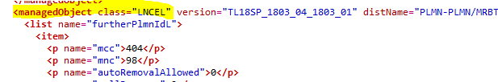  - Take the value from attribute <p name="administrativeState"  - If value is equal to 1, then the Cell will be in ACTIVE state.  - If value is equal to 0, then the Cell will be in HALT state.

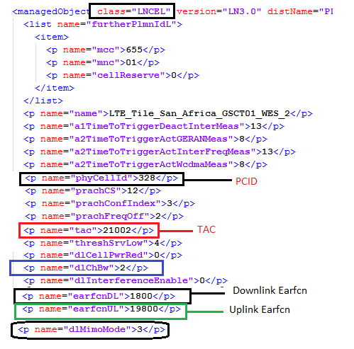

Cell Parameters for “MRBTS Version SBTS” for FDD CELLS

Downlink Earfcn | Optional | - Under:class="LNCEL_FDD"name="earfcnDL"  - E.g.: name="earfcnDL">1374</p>  So, first we need to search for class=LNCEL_FDD and in same line we can get the value of LNCEL-1.  For Eg::- class="LNCEL_FDD" version="xL18_1708_008" distName="PLMN-PLMN/MRBTS-900505/LNBTS-900505/LNCEL-1
Uplink Earfcn | Optional | - Under : Class="LNCEL_FDD"name=" earfcnUL"  - E.g.: name="earfcnUL">19374</p>

Cell Parameters for “MRBTS Version SBTS” for TDD CELLS

Downlink Earfcn & Uplink Earfcn for TDD Cell | Optional | - Under:class="LNCEL_TDD"name="earfcn"  - E.g.: name="earfcn">38800</p>  So, first we need to search for class=LNCEL_TDD and in same line we can get the value of LNCEL-1.  For Eg::- class="LNCEL_TDD" version="TL17A_1701_07_1701_06" distName="PLMN-PLMN/MRBTS-803949/LNBTS-803949/LNCEL-1  Note: - In class="LNCEL_TDD" the value of Downlink Earfcn & Uplink Earfcn remains the same.

5. IP Parsing eNodeB

Physical port

- To be parsed from class=“IVIF”, where the distName="PLMN-PLMN/MRBTS-xxx/LNBTS-xxx where xxx represent the eNodeB ID

Attributes | Importance | Parsing
Interface Name | [Mandatory] | - =Physical port
Node ID | [Mandatory] | - = from the distName
Physical Port C/Sh/S/I/P | [Mandatory] | - To be provided later.
IP address | [Optional] | - = attribute "localIpAddr"
Subnet Mask | [Optional] | - = attribute "netmask"
VLAN | [Optional] | - = attribute "vlanId"
Gateway | [Optional] | - From class=“IPRT”  - Deduce the range of IP from attribute "destIpAddr" and attribute "netmask"  - Match the above IP address with the deduce range of IP  - When matched take Gateway = attribute "gateway"

If class=”IVIF” not found then available, then take class=”FSTSCH”

- In the same class take the value under the attribute “ipIfDN” where the “userLabel” equal to “LTEU”, “LTEC” and “MPLANE”

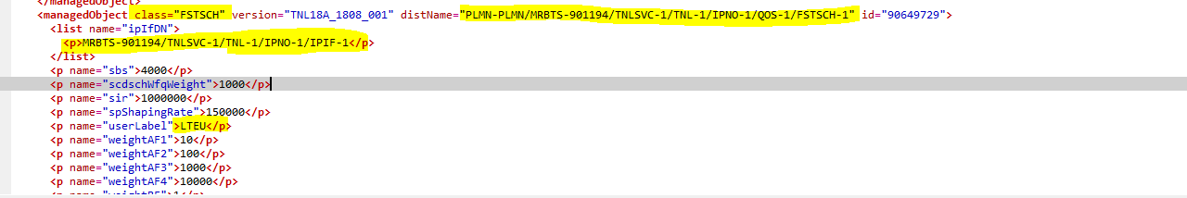
- Match this value of <list name="ipIfDN"> with the distname where the class=”IPADDRESSV4” is available and parse "localIpAddr" as IP address

- For “Vlan” check value of <list name="ipIfDN"> which we got under class=”FSTSCH” and match with class= “IPIF” distName available and get attribute of name="interfaceDN"

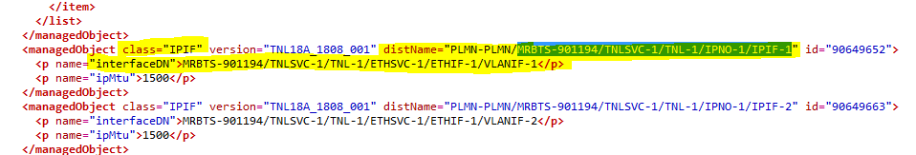

- Match attribute name="interfaceDN" get from class=”IPIF” under class=”VLANIF” and take vlanId as VLAN.

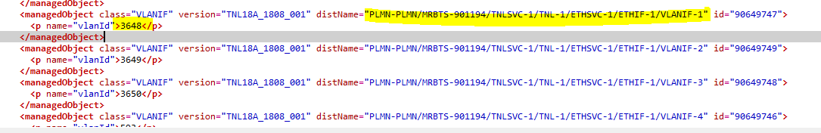

Attributes | Importance | Parsing
Interface Name | [Mandatory] | - =Physical port
Node ID | [Mandatory] | - = from the distName
Physical Port C/Sh/S/I/P | [Mandatory] | - To be provided later.
IP address | [Optional] | - = attribute "localIpAddr" under class=”IPADDRESSV4” parse as IP address
Subnet Mask | [Optional] | - = attribute "localIpPrefixLength" under class=”IPADDRESS4
VLAN | [Optional] | - = attribute "vlanId" as explained above
Gateway | [Optional] | - From class=“IPRT”  - Deduce the range of IP from attribute "destIpAddr" and attribute "netmask"  - Match the above IP address with the deduce range of IP  - When matched take Gateway = attribute "gateway"

IP Parsing SRAN

Physical port “SBTS”

- To be parsed from class=“IPIF”, where the distName="PLMN-PLMN/SBTS-xxx/TNL-y/IPNO-z/IPIF-x where xxx represent the node ID and each x represent an interface

Attributes | Importance | Parsing
Interface Name | [Mandatory] | - =Physical port
Node ID | [Mandatory] | - = from the distName
Physical Port C/Sh/S/I/P | [Mandatory] | - To be provided later.
IP address | [Optional] | - = attribute "localIpAddr"
Subnet Mask | [Optional] | - = attribute "localIpPrefixLength"
VLAN | [Optional] | - = attribute "vlanId" under class=“VLANIF”  - Matching is described in below snapshot
Gateway | [Optional] | - From class=“RTPOL”  - Match deduced IP address above with attribute "srcIpAddress"  - Take the attribute "routingTablePtr" for the deduced "srcIpAddress"  - From class=“IPRT” Put the value of "routingTablePtr" in distName="PLMN-PLMN/SBTS-5672/TNL-1/IPNO-1/Value_OF_routingTablePtr”  - Gateway= attribute "gateway"

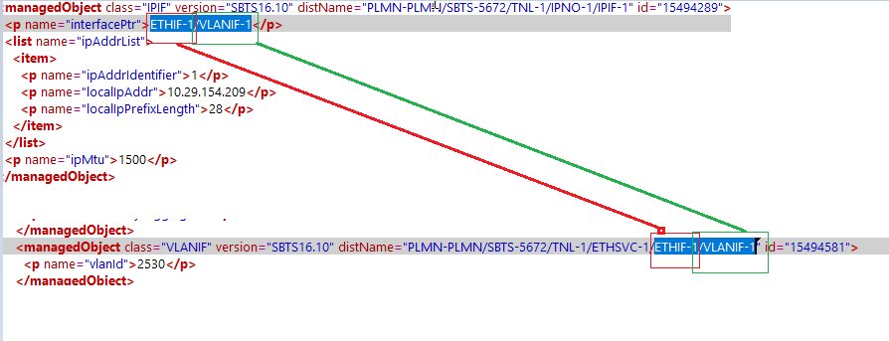

Physical Port “MRBTS” version “SBTS

- If you are not able to get IP Address from class=“IVIF”, then go to class=“IPADDRESSV4” where the distName="PLMN-PLMN/MRBTS-xxx/LNBTS-xxx where xxx represent the eNodeB ID.

Attributes | Importance | Parsing
Interface Name | [Mandatory] | - =Physical port
Description | [Optional] | - Match the section start by mrbts till IPIF in the distname example “MRBTS-905708/TNLSVC-1/TNL-1/IPNO-1/IPIF-7” with value under attribute “ipIfDN” under the class “FSTSCH” where the distname start with “PLMN-PLMN/MRBTS-ID  - Example in the below screen shot
Node ID | [Mandatory] | - = from the distName
Physical Port C/Sh/S/I/P | [Mandatory] | - To be provided later.
IP address | [Optional] | - = attribute "localIpAddr"
Subnet Mask | [Optional] | - = attribute "localIpPrefixLength"
VLAN | [Optional] | - In the line class=“IPADDRESSV4” i.e. class="IPADDRESSV4" version="TNL17A_1708_008" distName="PLMN-PLMN/MRBTS-900968/TNLSVC-1/TNL-1/IPNO-1/IPIF-1/IPADDRESSV4-1"  - Take the value of IPIF-1 the value will be 1  - Now go to class="IPIF", which has IPIF-1 in it.  - For example:- class="IPIF" version="TNL17A_1708_008" distName="PLMN-PLMN/MRBTS-900968/TNLSVC-1/TNL-1/IPNO-1/IPIF-1"  - Now under class=“IPIF”, you will get attribute interfaced take the value of VLANIF i.e. name="interfaceDN">MRBTS-900968/TNLSVC-1/TNL-1/ETHSVC-1/ETHIF-1/VLANIF-1, the value will be 1  - Now go to class="VLANIF", which has VLANIF-1 in it.  - Under the attribute name="vlanId", you will get the VLAN.
Gateway | [Optional] | - From class=“IPRT”  - Deduce the range of IP from attribute "destIpAddr" and attribute "netmask"  - Match the above IP address with the deduce range of IP  - When matched take Gateway = attribute "gateway"

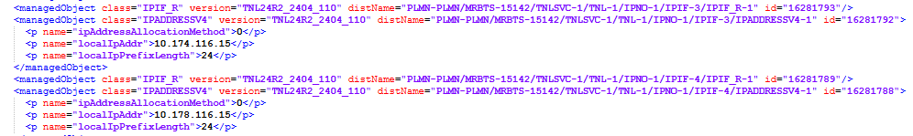

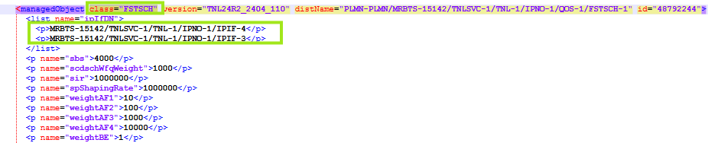

Additional info for eNodeB

- The attribute element to be increment by 1 for each new records

Category | Value | Note
Software version | eNodeB ID | In the same line where class=“MRBTS” take the version equal to the value after the version  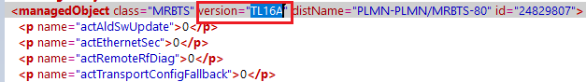

X2 Interface

- This section related to eNodeB MRBTS
- From class=“IPNO”, from the distName="PLMN-PLMN/MRBTS-800024 where after “MRBTS-” parse the eNodeB ID.
- In the same class take the Local_IP from the attribute "cPlaneIpAddress"
- From class=“LNADJ”, where the distName="PLMN-PLMN/MRBTS-eNodeB ID/LNBTS-eNodeB ID/LNADJ-X” (x is an integer), each LANDJ-X represent one additional info on the same Node and the attribute to be increment by 1 for each LANDJ-X
- From the same class take the Remote_IP from the attribute "cPlaneIpAddr"

Category | Value | Note
ADJNODE | eNodeB ID/LNADJ-X | - CONNECTION_TYPE=X2  - NODE_ID= IP_DERIVED
ASSOCIATION  // 1st association // | eNodeB ID/LNADJ-X | - LOCAL_IP= the value of "cPlaneIpAddr" in class=“IPNO”  - REMOTE_IP= the value of "cPlaneIpAddr" in class=“LNADJ”

2 S1-MME

- This section related to MRBTS
- From class=“IPNO”, from the distName="PLMN-PLMN/MRBTS-800024 where after “MRBTS-” parse the eNodeB ID.
- In the same class take the Local_IP from the attribute "mPlaneIpAddress"
- From class=“LNMME”, where the distName="PLMN-PLMN/MRBTS-xxx/LNBTS-xxx/LNMME-Y where xxx is the eNodeB ID, each Y represent an additional info
- From the same class take the Remote_IP from the attribute "ipAddrPrim"

Category | Value | Note
ADJNODE | eNodeB-ID /LNMME-Y | - CONNECTION_TYPE=S1-MME  - NODE_ID= IP_DERIVED
ASSOCIATION  // 1st association // | eNodeB-ID /LNMME-Y | - LOCAL_IP= the value of "mPlaneIpAddress" in class=“IPNO”  - REMOTE_IP= the value of "ipAddrPrim" in class=“ LNMME”

Case1: If class=”IPNO” doesn’t exist or does not have "mPlaneIpAddress" then follow given below rule for MRBTS

- This section related to MRBTS both version
- From class=“FSTSCH”, from the distName="PLMN-PLMN/MRBTS-ID where after “MRBTS-” parse the SBTS/MRBTS ID.
- In the same class take the value under the attribute “ipIfDN” where the “userLabel” equal to “LTEC”
- Match this value with the distname where the class=”IPADDRESSV4”
- Take LOCAL_IP=attribute “localIpAddr” under the above class
- If the IP did not deduce from above logic use this Logic for Local IP.
From class="IPADDRESSV4_R" Where distName="PLMN-PLMN/MRBTS-xxxx/TNLSVC-Y/TNL-Y/IPNO-Y/IPIF-Z/IPADDRESSV4-Y/IPADDRESSV4_R-Y where xxxx is the Node ID and y is integer and IPIF-Z is IPIF-3.
- LOCAL_IP= attribute " localIpAddrAllocated"
EX:-
LOCAL IP will be 10.33.1.90 in this case.
- From class=“LNMME”, where the distName="PLMN-PLMN/MRBTS-xxx/LNBTS-xxx/LNMME-Y where xxx is the SBTS/MRBTS ID, each Y represent an additional info
- From the same class take the Remote_IP from the attribute "ipAddrPrim"

Category | Value | Note
ADJNODE | MRBTS-ID /LNMME-Y | - CONNECTION_TYPE=S1-MME  - NODE_ID= IP_DERIVED
ASSOCIATION  // 1st association // | MRBTS-ID /LNMME-Y | - LOCAL_IP= the value of " localIpAddr" in class=“IPADDRESSV4” as described above  - REMOTE_IP= the value of "ipAddrPrim" in class=“ LNMME”

3 S1-U

If class=”IPNO” doesn’t exist or does not have "mPlaneIpAddress" then follow given below rule for MRBTS

- This section related to MRBTS version “SBTS/MRBTS” both
- From class=“FSTSCH”, from the distName="PLMN-PLMN/MRBTS-ID where after “MRBTS-” parse the SBTS/MRBTS ID.
- In the same class take the value under the attribute “ipIfDN” where the “userLabel” equal to “LTEU”
- Match this value with the distname where the class=”IPADDRESSV4”
- Take LOCAL_IP=attribute “localIpAddr” under the above class
- If the IP did not deduce from above logic use this Logic for Local IP.
From class="IPADDRESSV4_R" Where distName="PLMN-PLMN/MRBTS-xxxx/TNLSVC-Y/TNL-Y/IPNO-Y/IPIF-Z/IPADDRESSV4-Y/IPADDRESSV4_R-Y where xxxx is the Node ID and y is integer and IPIF-Z is IPIF-1.
- LOCAL_IP= attribute " localIpAddrAllocated"
Ex:-
Local ip will be 10.33.49.90 in this case.
- From class="GTPU", from the distName="PLMN-PLMN/MRBTS-xxx/LNBTS-xxx/ where xxx is the eNodeB ID
- From the same class, each attribute "sgwIpAddress" represent one remote IP, increase the attribute of the additional info by 1 for each remote IP

Category | Value | Note
ADJNODE | MRBTS-ID/GTPU-Y | - CONNECTION_TYPE=S1-U  - NODE_ID= IP_DERIVED
ASSOCIATION  // 1st association // | MRBTS-ID/GTPU-Y | - LOCAL_IP= the value of " localIpAddr" in class=“IPADDRESSV4” as described above REMOTE_IP= the value of "sgwIpAddress" in class=“ GTPU”

4.Additional attributes for eNodeB or SRAN in case of 4G

Category | Attribute | Value
RADIO | actUeBasedAnrIntraFreqLte | Take value from class="LNBTS" as shown below  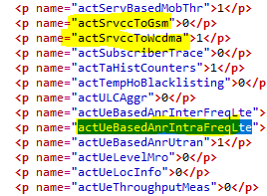
RADIO | actCSFBRedir | Take value from class="LNBTS" as shown below  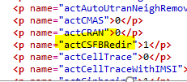
RADIO | actIfHo | Take value from class="LNBTS" as shown below  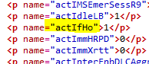
RADIO | actSrvccToGsm | Take value from class="LNBTS" as shown below
RADIO | actSrvccToWcdma | Take value from class="LNBTS" as shown below

Additional info for SRAN

Category | Value | Note
Software version | SRAN ID | In the same line where class=“SBTS” take the version equal to the value after the version  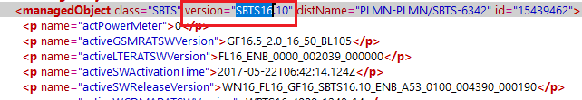

X2 Interface
- From class=“BTSSCL”, where the distName="PLMN-PLMN/SBTS-xxx/BTSSCL-Y xxx is the eNodeB ID and y is an integer
- From the same class, LOCAL_IP equal to attribute "ipV4Address1" under the attribute "cPlaneList" Or under class=”FSTSCH” take value of “ipIfDN” find same value of “iPIfDN” in class=”IPADDRESSV4” then take value of “localIpAddr”.
- From class=“LNADJ”, where the distName="PLMN-PLMN/SBTS-eNodeB ID/LNBTS-eNodeB ID/LNADJ-X” (x is an integer), each LANDJ-X represent one additional info on the same Node and the attribute to be increment by 1 for each LANDJ-X
- From the same class take the Remote_IP from the attribute "cPlaneIpAddr"
Category | Value | Note
ADJNODE | SRAN-ID/LNADJ-X | - CONNECTION_TYPE=X2  - NODE_ID= IP_DERIVED
ASSOCIATION  // 1st association // | SRAN-ID/LNADJ-X | - LOCAL_IP= the value of "ipV4Address1" in class=“BTSSCL” under the attribute "cPlaneList"  - REMOTE_IP= the value of "cPlaneIpAddr" in class=“LNADJ”

S1-MME

- From class= "MPLANE" where the distName="PLMN-PLMN/SBTS-xxx/MGMNT-Y/MPLANE-Y where xxx is the Node ID and Y is an integer
- LOCAL_IP= attribute "mPlaneIpAddress"

- If the IP did not deduce from above logic use this Logic for Local IP.
From class="IPADDRESSV4_R" Where distName="PLMN-PLMN/MRBTS-xxxx/TNLSVC-Y/TNL-Y/IPNO-Y/IPIF-Z/IPADDRESSV4-Y/IPADDRESSV4_R-Y where xxxx is the Node ID and y is integer and IPIF-Z is IPIF-3.
- LOCAL_IP= attribute " localIpAddrAllocated"
EX:-
LOCAL IP will be 10.33.1.90 in this case.
- From class=“LNMME”, where the distName="PLMN-PLMN/SBTS-xxx/LNBTS-xxx/LNMME-Y where xxx is the eNodeB ID, each Y represent an additional info
- From the same class take the Remote_IP from the attribute "ipAddrPrim"

Category | Value | Note
ADJNODE | SRAN-ID /LNMME-Y | - CONNECTION_TYPE=S1-MME  - NODE_ID= IP_DERIVED
ASSOCIATION  // 1st association // | SRAN-ID /LNMME-Y | - LOCAL_IP= the value of "mPlaneIpAddress" in class=“IPNO”/ the value of " localIpAddrAllocated " in class=“ IPADDRESSV4_R”  - REMOTE_IP= the value of "ipAddrPrim" in class=“ LNMME”

S1-U

- From class=“BTSSCL”, where the distName="PLMN-PLMN/SBTS-xxx/BTSSCL-Y xxx is the eNodeB ID and y is an integer
- From the same class, LOCAL_IP equal attribute "ipV4Address1" under the attribute "uPlaneList"
- If the IP did not deduce from above logic use this Logic for Local IP.
From class="IPADDRESSV4_R" Where distName="PLMN-PLMN/MRBTS-xxxx/TNLSVC-Y/TNL-Y/IPNO-Y/IPIF-Z/IPADDRESSV4-Y/IPADDRESSV4_R-Y where xxxx is the Node ID and y is integer and IPIF-Z is IPIF-1.
- LOCAL_IP= attribute " localIpAddrAllocated"
Ex:-
Local ip will be 10.33.49.90 in this case.
- From class="GTPU", from the distName="PLMN-PLMN/SBTS-xxx/LNBTS-xxx/ where xxx is the eNodeB ID
- From the same class, each attribute "sgwIpAddress" represent one remote IP, increase the attribute of the additional info by 1 for each remote IP
Category | Value | Note
ADJNODE | SRAN-ID/GTPU-Y | - CONNECTION_TYPE=S1-U  - NODE_ID= IP_DERIVED
ASSOCIATION  // 1st association // | eNodeB-ID/GTPU-Y | - LOCAL_IP= the value of "uPlaneIpAddress" in class=“IPNO”/  the value of " localIpAddrAllocated " in class=“ IPADDRESSV4_R”  - REMOTE_IP= the value of "sgwIpAddress" in class=“ GTPU”

9.Additional info for LTE CELL

Category | Attribute | Value | Note
RADIO | vswrMajorAlarm | antlId=* | Divide the value by 10. If value is 26 then it is 2.6
RADIO | vswrMinorAlarm | antlId=* | Divide the value by 10. If value is 15 then it is 1.5
RADIO | qRxLevMin | Take value from class="LNCEL" as shown below  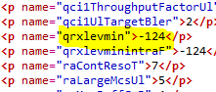
RADIO | dlMimoMode | Take value from class="LNCEL" as shown below  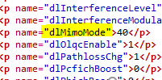
RADIO | t300 | Take value from class="LNCEL" as shown below  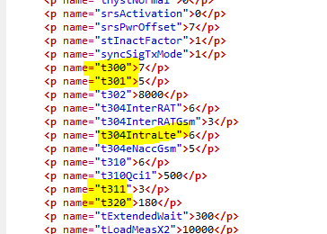
RADIO | t301 | Take value from class="LNCEL" as shown below
RADIO | t304IntraLte | Take value from class="LNCEL" as shown below
RADIO | t311 | Take value from class="LNCEL" as shown below
RADIO | t320 | Take value from class="LNCEL" as shown below

- For Version:- TL16,TL16A,FL16,FL16A.

1.Take the id <p name="antlId"> from class="LCELL" version="TL16" or “TL16A” or "FL16" "FL16A" distName="PLMN-PLMN/MRBTS or SBTS -XXXX/BTSSCL-Y/LCELL-ZZZ" (where X,Y,Z are integer).
2. Match the class=LCELL with LNCELL to deduce the cell id.
3. Map ANTL-id from class="ANTL" version="TL16" or “TL16A” or "FL16" "FL16A"distName="PLMN-PLMN/MRBTS-XXXX/ANTL-Y"(where X and Y is integer)
3. Take the value from attribute
<p name="vswrMajorAlarm">xx</p> and <p name="vswrMinorAlarm">yy</p> (where x and y is integer)
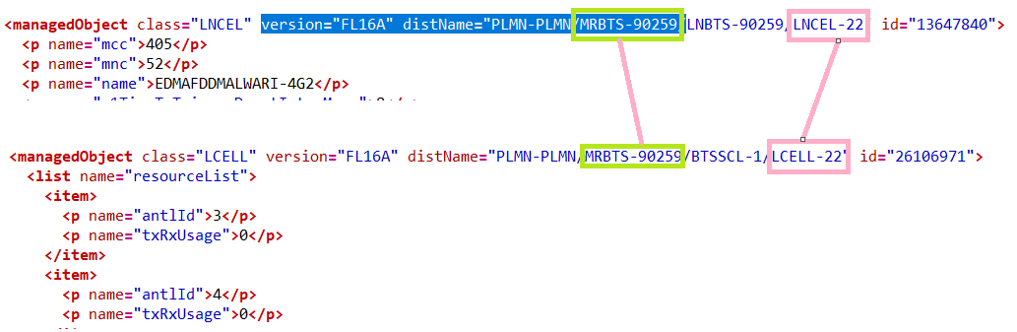
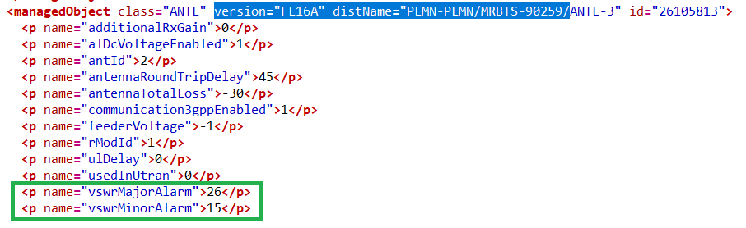

- For Version-TL17, TL17A, FL17,FL17A
- Take the ID from “<managedObject class="CHANNEL" version="MNL17A_" distName="PLMN-PLMN/MRBTS or SBTS-XXX/MNL-1/MNLENT-1/CELLMAPPING-1/LCELL-Y/CHANNELGROUP-1/CHANNEL-Z”
- Take the ANTL ID from <p name="antlDN">MRBTS-902232/EQM-1/APEQM-1/RMOD-1/ANTL-5</p>
- Match the class=LCELL with LNCELL to deduce the cell id.
- Take VSWR value from ‘<managedObject class="ANTL" version="EQM17_1701_007" distName="PLMN-PLMN/MRBTS-902232/EQM-1/APEQM-1/RMOD-1/ANTL-5"’

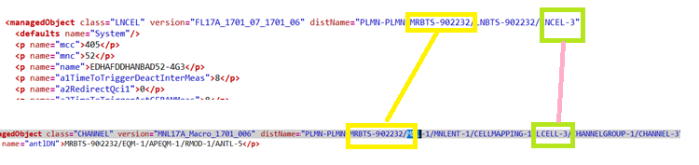

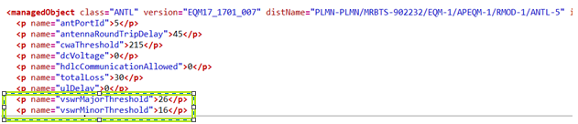

9.1 Rach Root Sequence

Take the value of Rach Root Sequence under attribute <p name="rootSeqIndex"> from class <managedObject class="LNCEL".
If not present in class="LNCEL" ,then take the value under attribute <p name="rootSeqIndex"> from class <managedObject class="LNCEL_FDD" & <managedObject class="LNCEL_TDD" respectively.

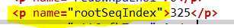

9.2 RET Information

RET parameter will parse as below.
- From class=”LNBTS” take MRBTS for that node.

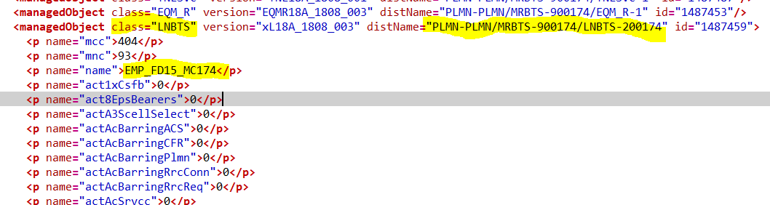

- check class=”LNCEL” for that MRBTS
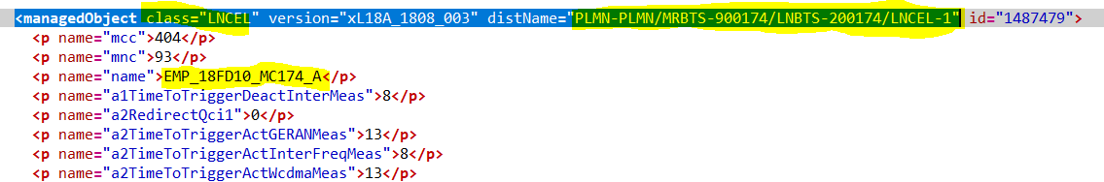

- From the above step we got “LNCEL-1” so we match “LCELL-1” in distName under class= “CHANNEL”

Example:

distName="PLMN-PLMN/MRBTS-900174/MNL-1/MNLENT-1/CELLMAPPING-1/LCELL-1

under class”CHANNEL” take attribute name=”antlDN”

example:

<p name="antlDN">MRBTS-900174/EQM-1/APEQM-1/RMOD-1/ANTL-1</p>

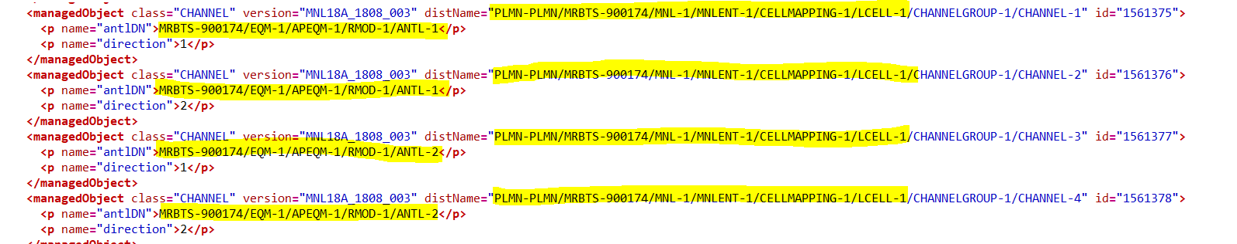

If antlDN did not found take attribute “ressourceDN”.

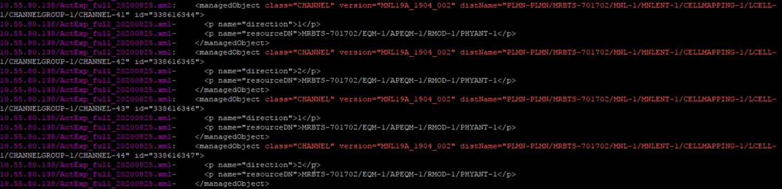

- From class “RETU_R” for same MRBTS, Deduce antlDNList.

SS:-
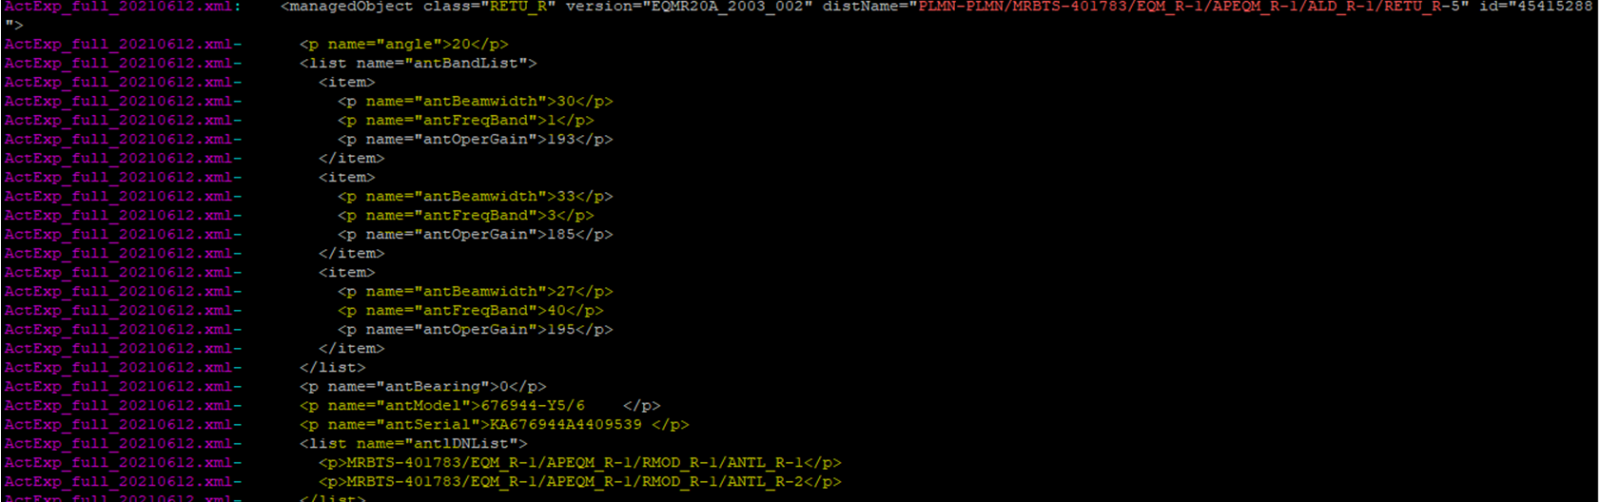
- Replace “_R” from deduce value of step 4 and match it with deduce value of step 3.

This is how cell will map to RETU_R class.

- Below attributes will taken from class=”RETU_R as per step 7.

Object Type | Category | Attribute | Value
LTE CELL | RET | E Tilt
LTE CELL | RET | Max E Tilt
LTE CELL | RET | Min E Tilt
LTE CELL | RET | Operational State
LTE CELL | RET | Ret Subunit iD
LTE CELL | RET | Antenna Model
LTE CELL | RET | Antenna Serial Number
LTE CELL | RET | Antenna Group

- Below is attribute and dumps mapping:-

Attribute | Parameters detail
E Tilt | angle
Max E Tilt | maxangle
Min E Tilt | minangle
Operational State | opertionalstate
Ret Subunit iD | Sub unit Number
Antenna Model | antmodel
Antenna Serial Number | ant serial
Antenna Group | antDNlist

Ex:- E Tilt

SIWA Parameters
Please parse following parameters for SIWA scope in add info. Where ever value is not mentioned please keep blank. Logic will be provided later.

Object Type | Object ID | Category | Attribute | Value | Note
LTE_Site |  | SIWA | MME ID
LTE cell |  | SIWA | Band | <below table >
LTE cell |  | SIWA | RS Power | <as per below logic>
EnodeB/SRAN |  | SIWA | eNB Model No
EnodeB/SRAN |  | SIWA | RRU model no
LTE cell |  | SIWA | MIMO Configuration
LTE_Site |  | SIWA | Connectivity Type | IP
LTE cell |  | SIWA | No of Active users - License supported
EnodeB/SRAN |  | SIWA | Total Aggregate bandwidth provisioned per eNB
EnodeB/SRAN |  | SIWA | Active Technology on SRAN BTS | <as per below logic >
LTE cell |  | SIWA | Cell range
EnodeB/SRAN |  | SIWA | SRAN | “Yes” if parent node is SRAN  Otherwise “NO”
EnodeB/SRAN |  | SIWA | BBU manufacturer | NSN
EnodeB/SRAN |  | SIWA | RRU manufacturer | NSN
LTE cell |  | SIWA | DL Power | Same as attribute power which is already coming in addInfo
LTE cell |  | SIWA | RRU Model No
EnodeB/SRAN |  | SIWA | Latitude
EnodeB/SRAN |  | SIWA | Longitude
LTE cell |  | SIWA | Circle | < same as attriute “MNC”,which is already parsing>
EnodeB/SRAN |  | SIWA | eNB Model No
EnodeB/SRAN |  | SIWA | BBU Model No
EnodeB/SRAN |  | SIVA | No of VLANs per eNB | <below logic>

Band:

The value of Band for LTE cells can be extracted as below below:

Dlearfcn
From | To | Value
0 | 599 | 2100
600 | 1199 | 1900
3450 | 3799 | 900
1200 | 1949 | 1800
2400 | 2649 | 850
2750 | 3449 | 2600
38650 | 39649 | 2300
39650 | 41589 | 2500

Active Technology on SRAN BTS:
If parent node is SRAN then value is supported technologies for that SRAN node.

No of VLANs per Enb : Count of VLANs of the parent node.

RS Power: the value of RS power can be extracted as per below formula

RS Power = (pMax – dlCellPwrRed -10*LOG10(redBwMaxRbDl*12))+ dlRsBoost.

Extract the value from the attribute <p name="pMax"> under class <managedObject class="LNCEL"
So, pMax= (value extracted from <p name="pMax"> /10).

Extract the value from the attribute <p name="dlCellPwrRed"> under class <managedObject class="LNCEL" if not present in the above class the check in class <managedObject class="LNCEL_FDD" or <managedObject class="LNCEL_TDD"
So, dlCellPwrRed =(value extracted from <p name="dlCellPwrRed">/10).

Take the value for redBwMaxRbDl from the attribute <p name="redBwMaxRbDl"> and the value of dlRsBoost from the attribute <p name="dlRsBoost"> under class <managedObject class="LNCEL".

10.Additional New

10.1 LNBTS Name

To be added for SRAN or eNodeB deduced from SBTS or MRBTS Classes.

Category= LNBTS_name
Value= name under LNBTS under MRBTS or SBTS.

Attribute name=Category_Value.

Attribute | Value | Category | Note
LNBTS_MUMFDLTEGROWELPH2IB | MUMFDLTEGROWELPH2IB | LNBTS_name

10.2 LNBTS enbName

To be added for SRAN or eNodeB deduced from SBTS or MRBTS Classes.

Category= LNBTS_enbName
Value= enbName under LNBTS under MRBTS or SBTS.

Attribute name=Category_Value.

Attribute | Value | Category | Note
LNBTS_enbName_MUMFDLTEDMARTKHARIO | MUMFDLTEDMARTKHARIO | LNBTS_enbName

10.3 SBTS/MRBTS btsName

To be added for SRAN or eNodeB deduced from SBTS or MRBTS Classes.

Category= SBTS_MRBTS_btsName
Value= btsName or sbtsName under class="SBTS" or class =”MRBTS”

Attribute name=Category_Value.

Attribute | Value | Category | Note
SBTS_MRBTS_btsName | SBTS-MUMFDLTELODHAVENEZIB_905404 | SBTS_MRBTS_btsName

10.4 Lat/Long parsing rule

Under <managedObject class="GNSSE_R" take value of <p name="gnssAntennaLatitude"> for latitude and <p name="gnssAntennaLongitude"> for Longitude and divide it with 10 million(10^7).
Take the corresponding value of parent node for particular MRBTS.

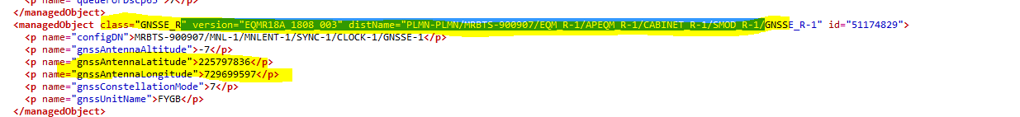

Example:

<p name="gnssAntennaLatitude">225797836</p>

So Latitude will be 22.5797836

<p name="gnssAntennaLongitude">729699597</p>

So Longitude will be 72.9699597

Category | Attribute | Value
enodeb | latitude | Value of latitude
enodeb | longitude | Value of longitude

4G Cell to RRU Mapping

- From class=”LNBTS” take MRBTS for that node.

- check class=”LNCEL” for that MRBTS

- From the above step we got “LNCEL-1” so we match “LCELL-1” in distName under class= “CHANNEL”

Example:

distName="PLMN-PLMN/MRBTS-900174/MNL-1/MNLENT-1/CELLMAPPING-1/LCELL-1

under class”CHANNEL” take attribute name=”antlDN”

example:

<p name="antlDN">MRBTS-900174/EQM-1/APEQM-1/RMOD-1/ANTL-1</p>

If antlDN did not found take attribute “ressourceDN”.

- under class”CHANNEL” take attribute name=”antlDN”/resourceDN till RMOD type, and match it with attribute name=”configDN” under class= ”RMOD_R”

so we match attribute like given below screenshots:

name=”antlDN

<p name="antlDN">MRBTS-900174/EQM-1/APEQM-1/RMOD-1

name=”configDN”

i.e. <p name="configDN">MRBTS-900714/EQM-1/APEQM-1/RMOD-1</p>

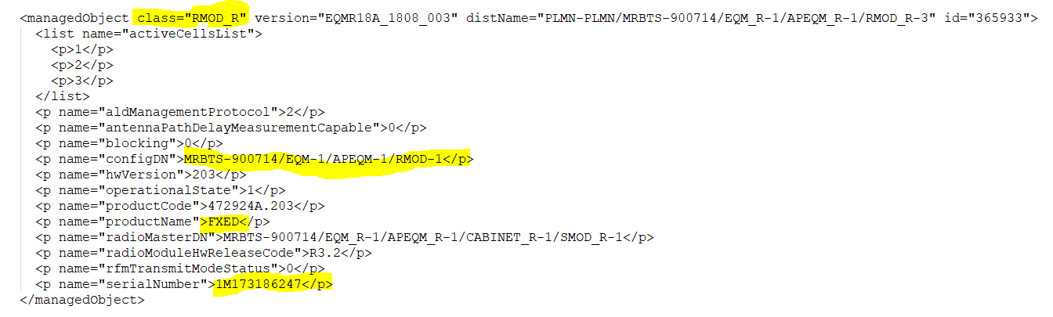

For cell to RRU mapping from class="RMOD_R”, parse the value of name="productName" in RU Model and name="serialNumber" in Serial Number of additionalinfo.

Object ID | Object Type | Attribute | Value | Category
CELLID | LTECell | Serial Number | Value of SerialNumber: Value of SerialNumber | RADIO
CELLID | LTECell | RU Model | Value of productName: Value of productName | RADIO

Physical Site ID

- Get the value of “siteTemplateName” attribute under class=”LNBTS” and map with the node.

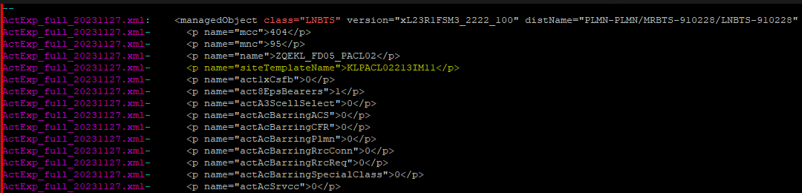

So Physical Site ID will be : KLPACL02213IM11

elementId | elementType | attribute | Value | category | note
MRBTS-123 | eNodeB/SRAN | Physical Site Id | Value of attribute “siteTemplateName” | Physical Site

11. SRAN node containing classes with extra tags

Note (Special case): For node type “SRAN” & in their dump each classes have some extra tags like below for example class=”MRBTS” here it is with extra tags “com.nokia.srbts:” which is extra than “MRBTS” so we will consider the value after “:” and mapped the class and apply the rule accordingly.

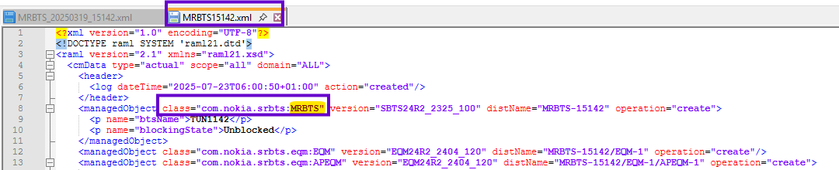

So please exclude the extra tags in each class which will be before “:” and consider the existing rule accordingly.

There is a list of few classes with extra tags & without extra tags which will be considered.

